Systematic Approach to CXR:

Overview:

* ABCDEF:
  + A-Airways
  + B-Bones (and soft tissue)
  + C-Cardiac silhouette (+mediastinum)
  + D-diaphragm (and gastric bubble)
  + E-Effusions
  + F-“Fields” (lung fields)
    - Also: TLD + surgeries

================================================================

A: Airways:

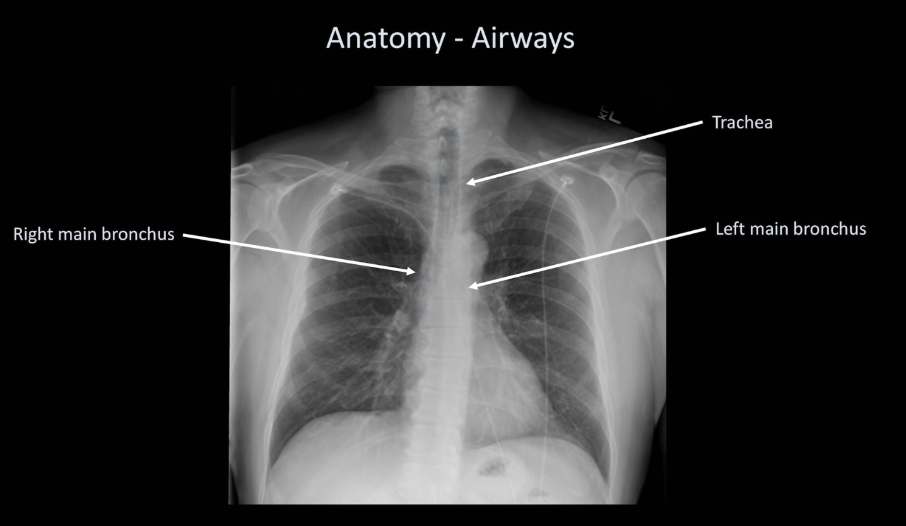

* Possible pathologies in airway:
  + Narrowed
  + Deviated
  + Containing foreign objects

B: Bones:

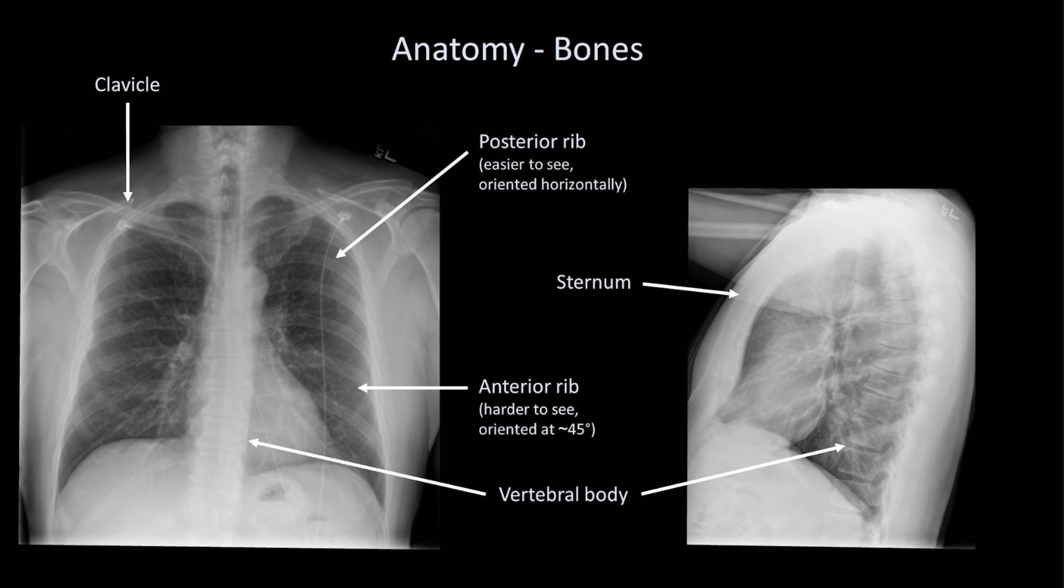

C: Cardiac Sillhouette + Mediastinum

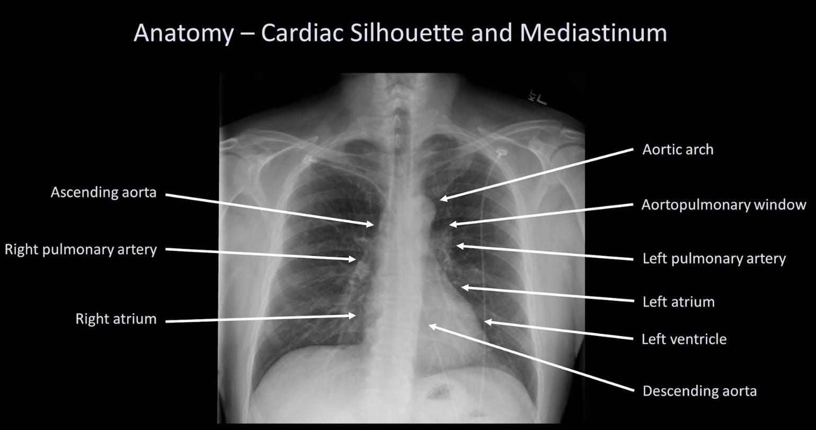

D: Diaphragms (+pleura)

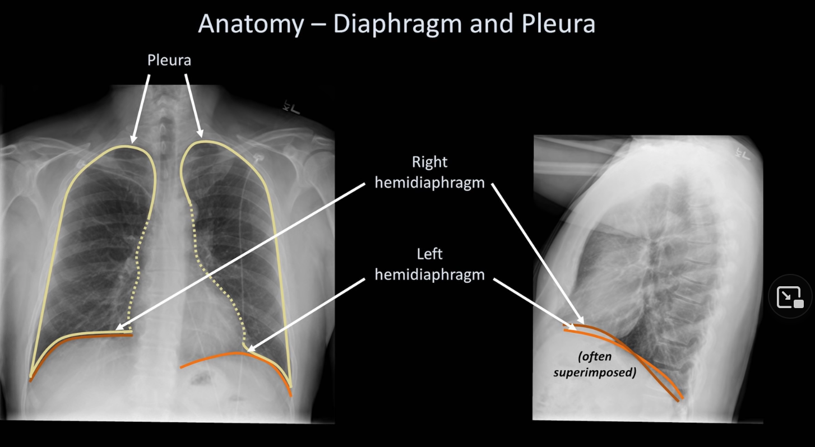

E: Effusions:

F: Fields (Lungs)

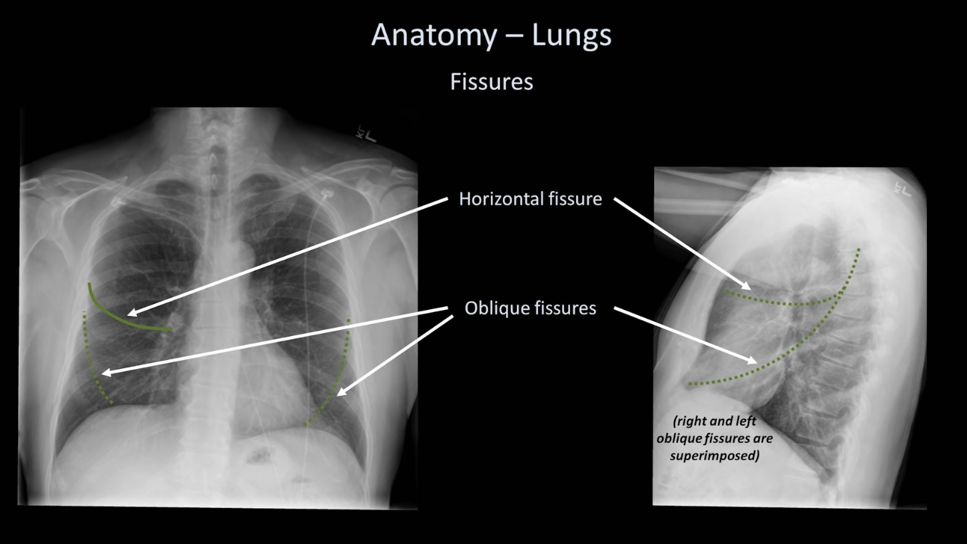

Assessing Technical Quality of a CXR

Factors affecting technical quality of a CXR:

* Rotation
  + The patient can be rotated in any of the three planes.
  + Bending forward?
    - Look at relationship between **clavicle** and **lung apex**. There should be some lung apex over the clavicle.

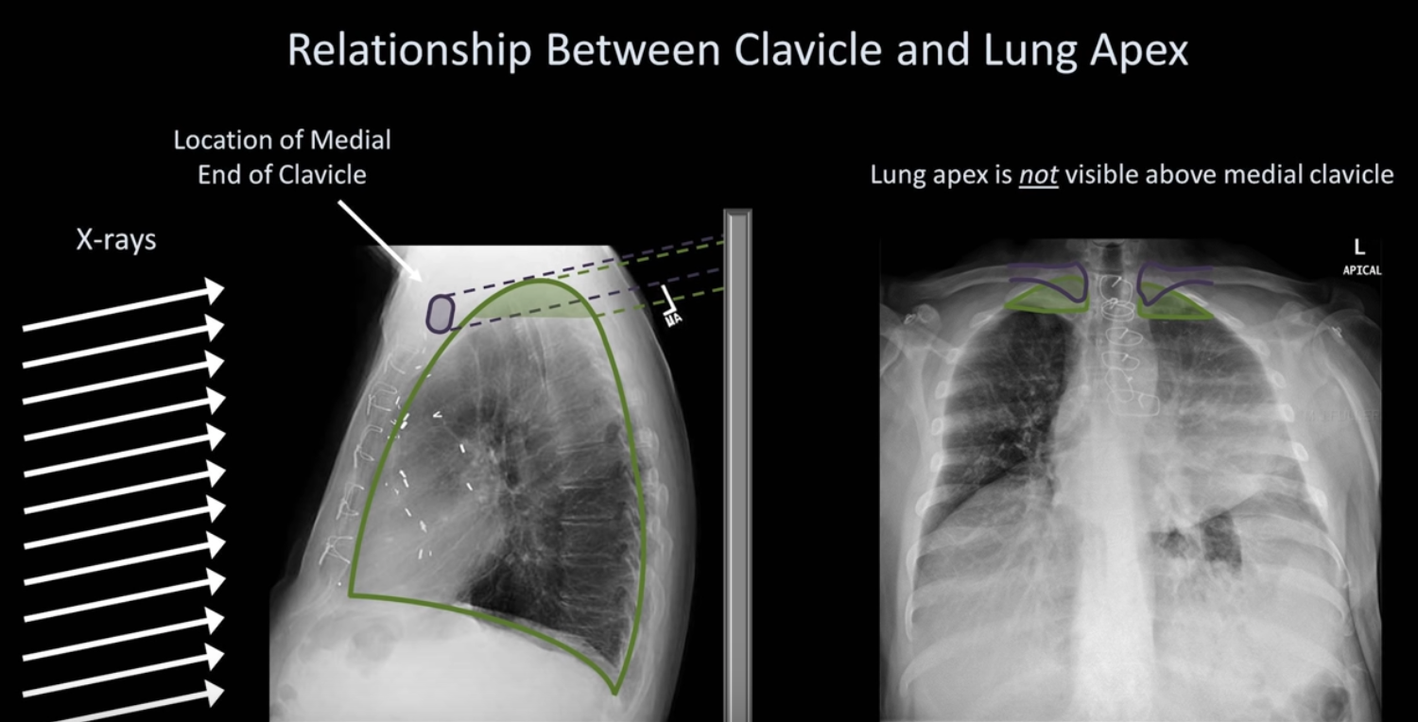

* + Bending to the **side?**
    - Look at relationship between clavicle and **spinous processes**
    - If there is rotation, the spinous processes will be closer to the clavicle on the side that is rotated forward

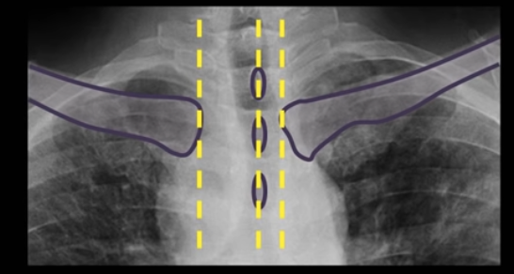

* Inadequate inspiration
  + 9-10 **posterior** ribs should be visible
    - Remember: the posterior ribs are the horizontal ones : )
  + Pay **very** close attention to CXR below, and in particular the appearance of the first rib
  + 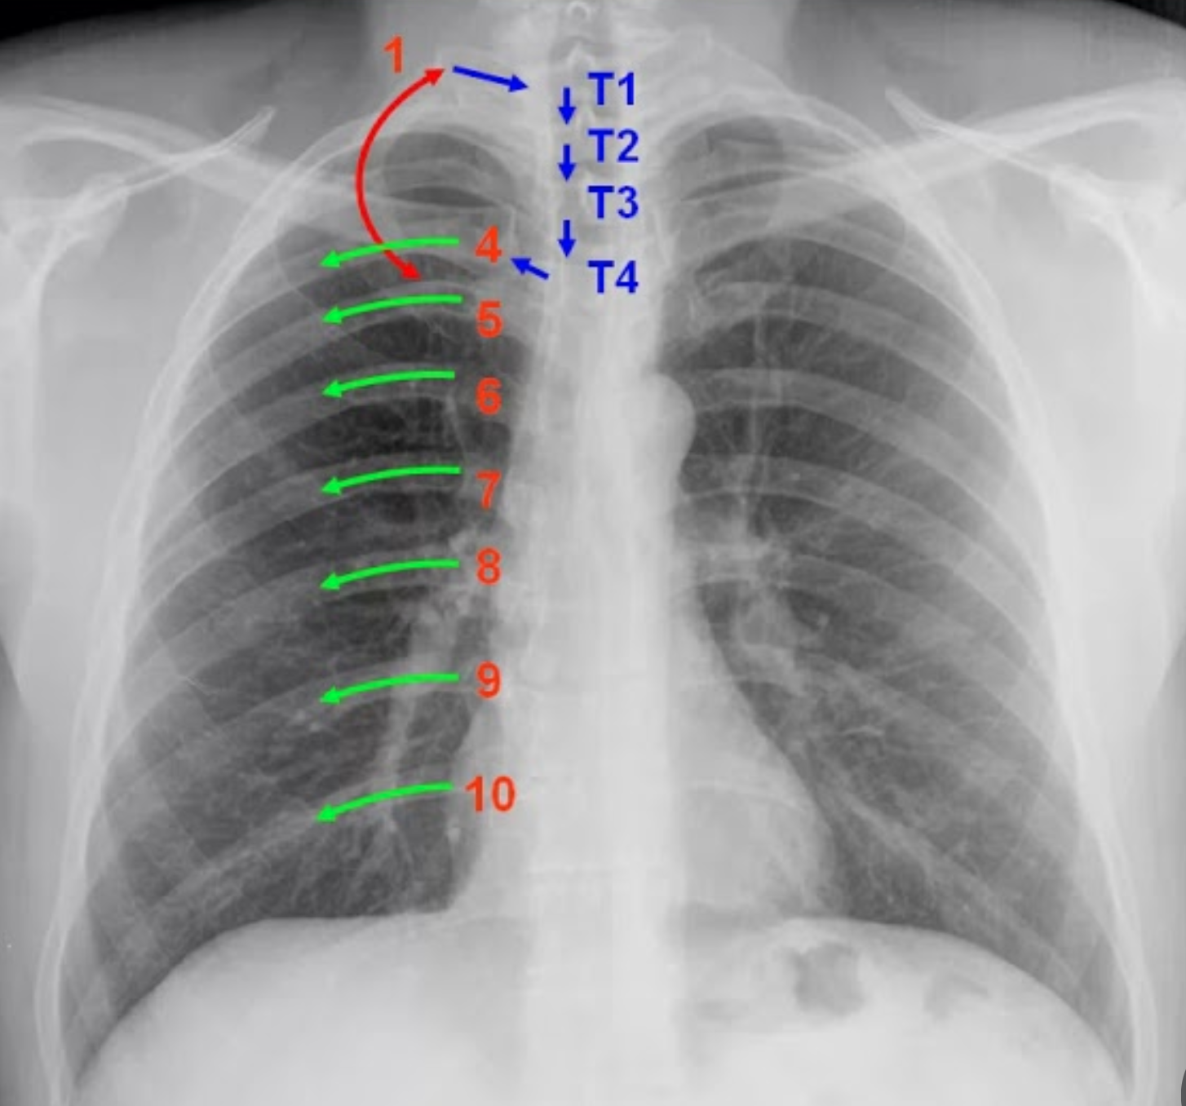
  + Consequences of inadequate inspiration:
    - Lung volumes appearly falsely low
    - Lung markings appear falsely prominent (🡪 false appearance of pulm. Edema)
    - Cardiac silhouette/mediastinum appear falsely enlarged
  + A thought: poor inspiratory effort and low lung volumes (e.g. restrictive lung dz)
* Suboptimal penetration:
  + Physical factors which determine “low exposure” vs. “high exposure”:
    - Duration of exposure (*measured in* ***milliamp seconds/mAs)***
    - Energy of photons (kVp)
    - And source-to-image distance (SID)
      * All *three* can be altered by the radiology tech
  + The above factors determine both contrast and overall film brightness (*or “optical density”)*

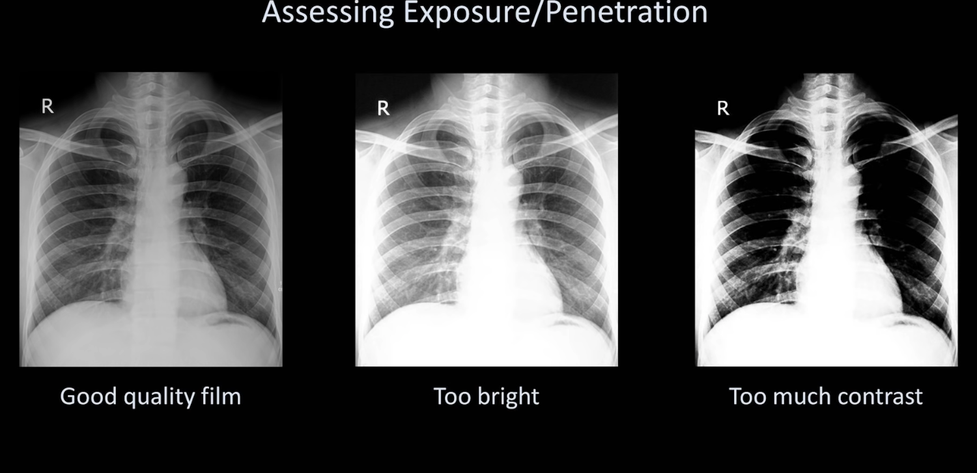

* How to determine when there is appropriate penetration?
  + 🡪 The **vertebral bodies should be just barely visible**
  + Look at the intervertebral spaces